**Software Engineering (Fall 2017)**

Prof. Jonathan Lee (李允中)

CSIE Department

National Taiwan University

* **CSIE 5040**
  + Instructor: Prof. Jonathan Lee (李允中)
  + *Office: 513*
  + *Email:* [jlee@csie.ntu.edu.tw](mailto:jlee@csie.ntu.edu.tw)
  + *Class Hours: Tuesday 1:20 – 4:20, CS Building 110*
  + *Office Hours: by appointment*
* **What’s Software Engineering?**
* Software engineering is the application of engineering to software.
* The application of systematic, disciplined, and quantifiable approaches to the design, development, operation, and maintenance of software, and the study of these approaches.
* First introduced in NATO Software Engineering Conference in 1968.
* What you will learn from this course is to build awareness of software process and develop your own software development and maintenance processes.
* **Course Outline**

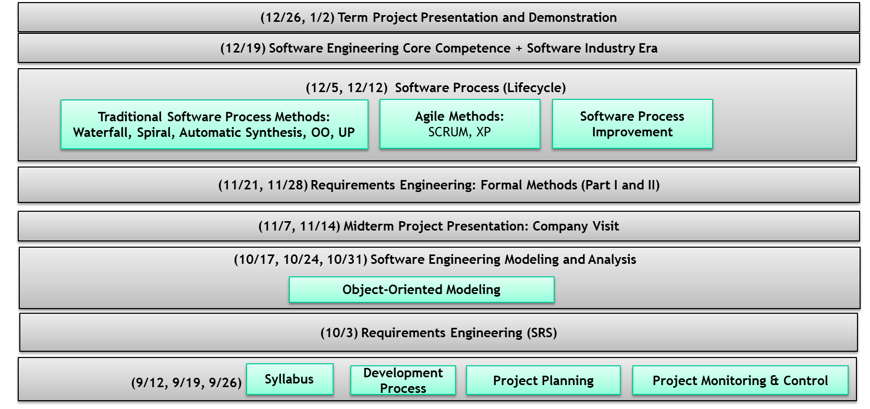

|  |  |
| --- | --- |
| * **Grading**   + Class attendance and participation (25%)   + Visit two Information Technology companies in Taiwan for each team (30%) (Presentation)   + Term project: Instant Messenger (45%) (Presentation and SRS, PEP, Meeting minutes, SDD, Demonstration) | * **Course Materials & Reference**   + Text Book:李允中, *軟體工程*, 台灣軟體工程學會, 2013   + Course materials and slides at URL, https://ceiba.ntu.edu.tw/1061CSIE5040_ |

©2017 Jonathan Lee, CSIE Department, National Taiwan University.